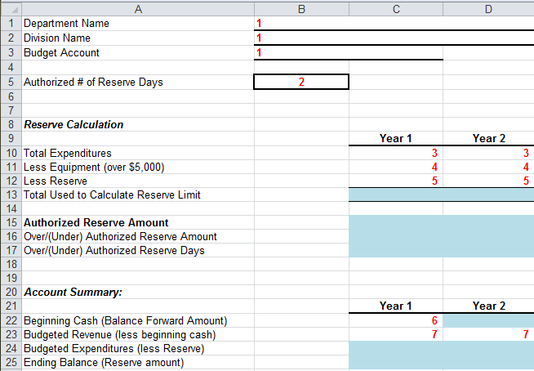
1 - Enter Department, Division and Budget Account in column B rows 1-3.
2 - Enter the authorized or appropriate number of reserve days to be maintained by the budget account in cell B5.
3 - Enter the total expenditures for each year of the biennium in cells C10 and D10. This amount can easily be located in NEBS by clicking on the Summary tab – Category View.
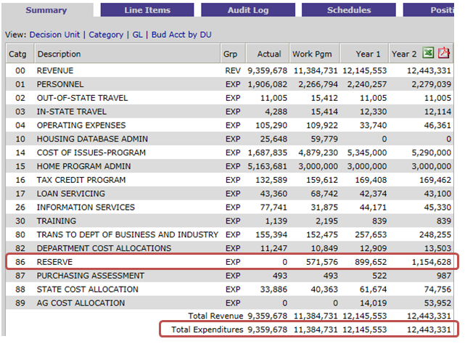

4 - Enter the total amount of Capital Items (Equipment > $5,000, Internally Developed Software > $100K, Debt Services, Principal portion of capital lease payments, and General Fund payback) for each year of the biennium in cells C11 and D11 as a negative number. This amount can easily be found by clicking on the Line Items tab, filter for "Display all Decision Units", and then sorting by GL. Look for GL 7770, 8250, 8270, 8370, 8720, 8410, etc.
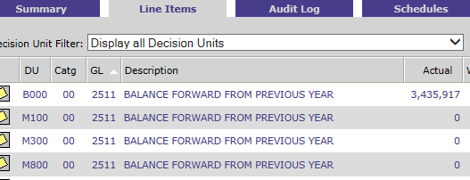
5- Enter the Reserve amount for each year as a negative number in cells C12 and D12. This amount can easily be located in NEBS by clicking on the Summary tab - Category view. (See screenshot in item #3).
6 - Enter the Beginning Cash (Balance Forward Amount) for year 1 in cell C22. This amount can easily be located in NEBS by clicking on the Summary tab - GL view (GL 2511 or 2512).
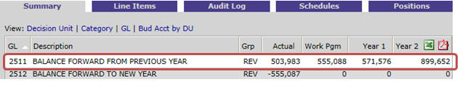
7 - Enter the Budgeted Revenue (less beginning cash) for year 1 in cell C23. This amount can easily be located in NEBS by clicking on the Summary tab - Category view by taking total in Cat 00 less the amount entered in cell C22. (See calculations below).
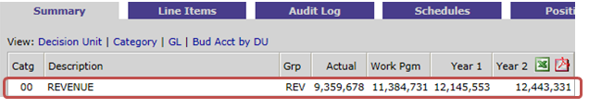
Year 1 - $12,145,553 – $571,576 = $11,573,977
Year 2 - $12,443,331 - $899,652 = $11,543,679
The Ending Balance (Reserve Amount) should equal the Reserve amount in the Reserve Calculation.

See completed sample below:
